Activity-APPLICATION BUILDING USING WEKA TOOL

Name: Y.Vamsi Babu
Reg.NO: 192311145

- Weather-Based Play Prediction
Build a WEKA application that predicts whether a person should play outdoors based on weather conditions.
  - Dataset: Outlook, Temperature, Humidity, Windy
  - Target: Play (Yes/No) • Algorithm: J48 Decision Tree
  - Tasks:
    - Load the dataset into WEKA.
    - Preprocess the data.
    - Apply J48.
    - Visualize the decision tree.
    - Predict Play for a new weather condition.

- Flower Species Classification
Build a WEKA application that identifies the species of a flower from its physical measurements.
  - Dataset: Iris dataset
  - Attributes: Sepal Length, Sepal Width, Petal Length, Petal Width
  - Target: Iris Species
  - Algorithm: J48 or Naive Bayes
  - Tasks:
    - Load the Iris dataset.
    - Select the classification algorithm.
    - Train the model.
    - Evaluate its accuracy.
    - Classify a new flower.

Answers:
- Weather-Based Play Prediction
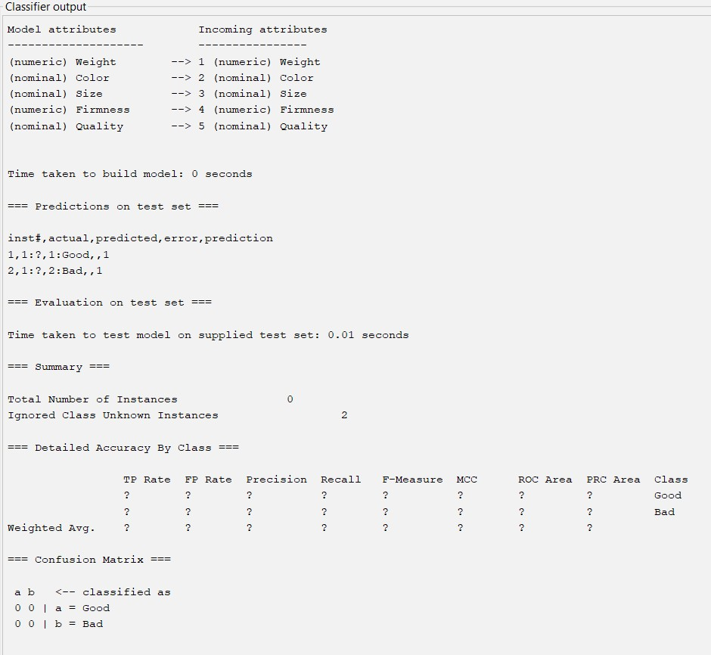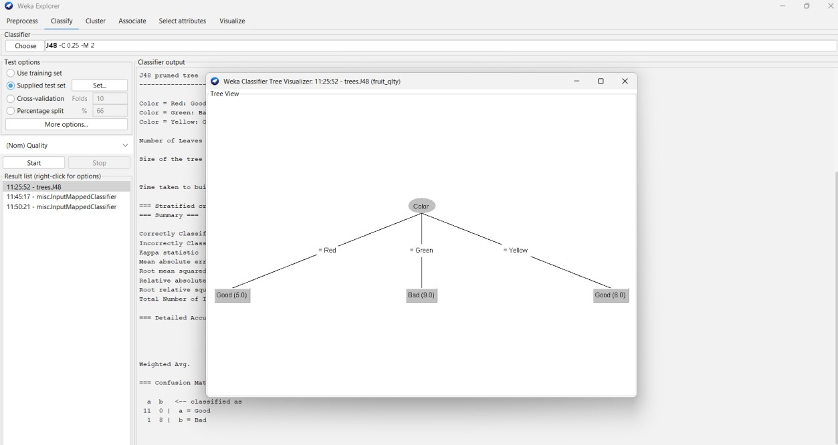

- Flower Species Classification
